# Notes and Reflections

**I was able to make very effective use of study groups this Int-set, and working through the problems with Siddhartan helped me understand them better. I now know the basic ideas behind this, although the nasty algebra can still get nasty at times, and I’m not sure I can reliably solve many-body versions of these problems.**

# Table of Contents

Notes and Reflections

Table of Contents

More Boats!

Electric Skateboards

Segways

Just a pendulum

A perfect segway

Massy segway

*Solutions begin on next page*

# More Boats!

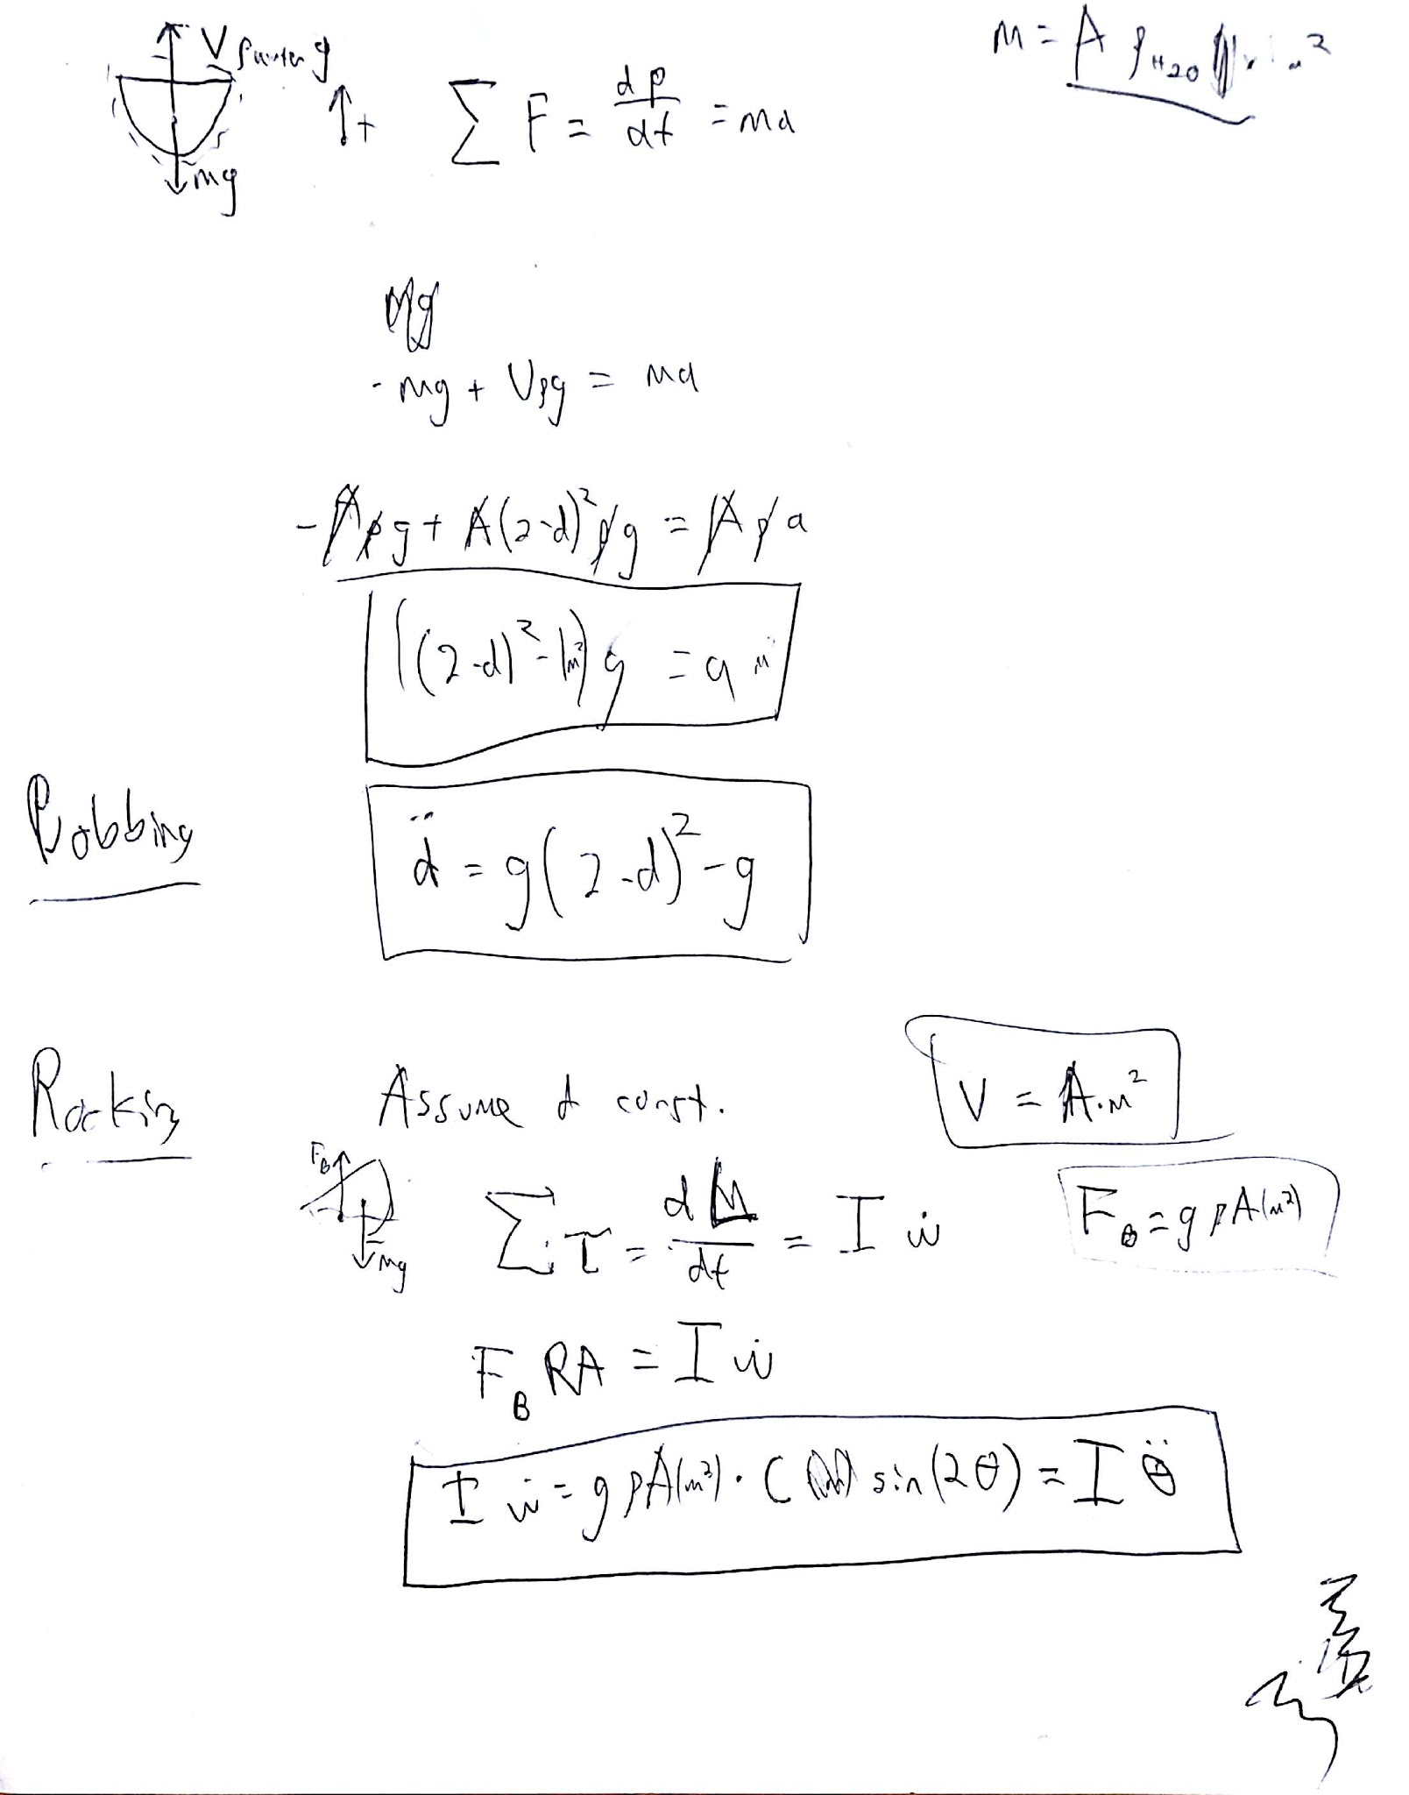

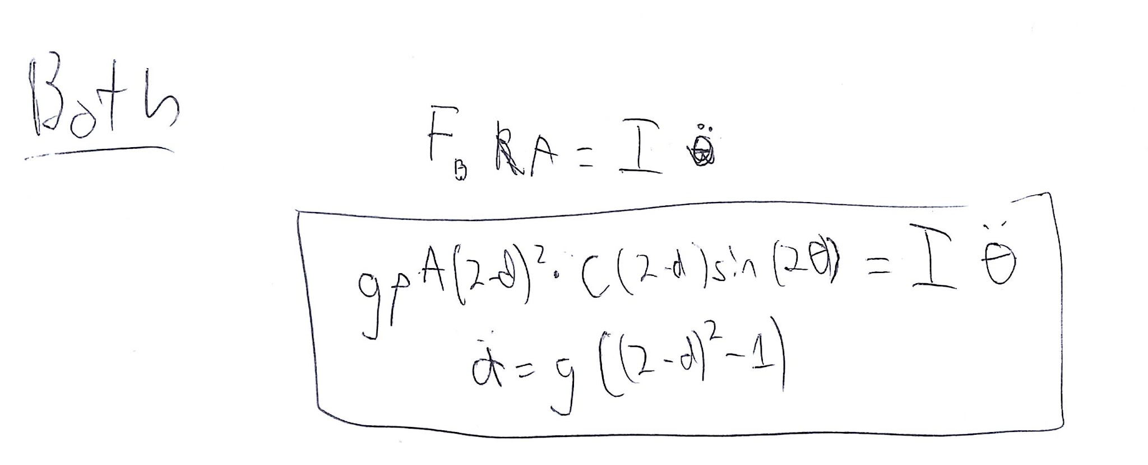

# Electric Skateboards

Obligatory xkcd

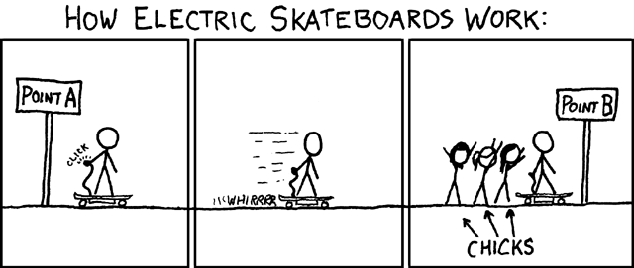

Step 1: FBD

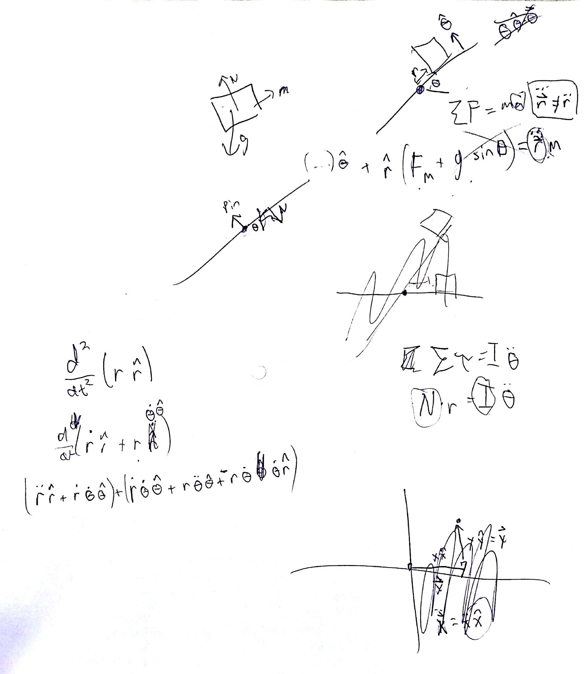

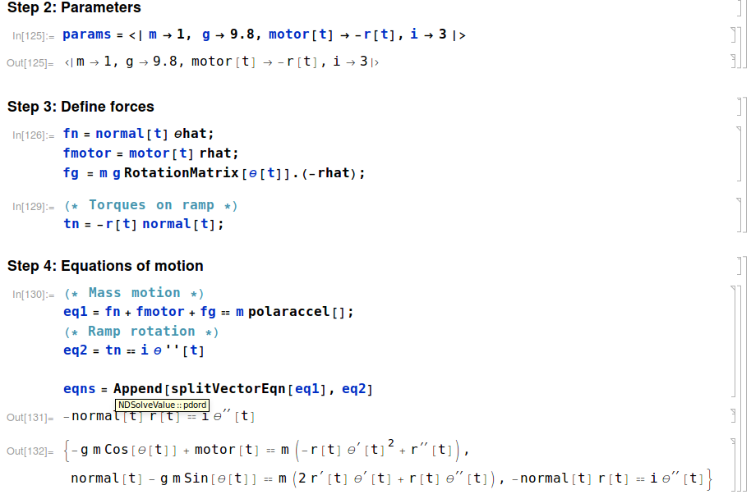

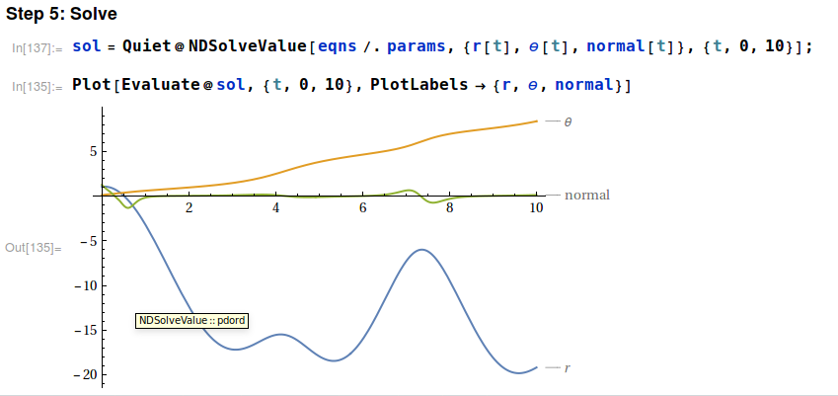

Note that a proper solution would define initial conditions. In this case, I just let *Mathematica* guess some.

# SegwaysF2TB6VKQMAUBrhJ7dLe0LQQC.jpg

## Just a pendulum

Step 1: FBD

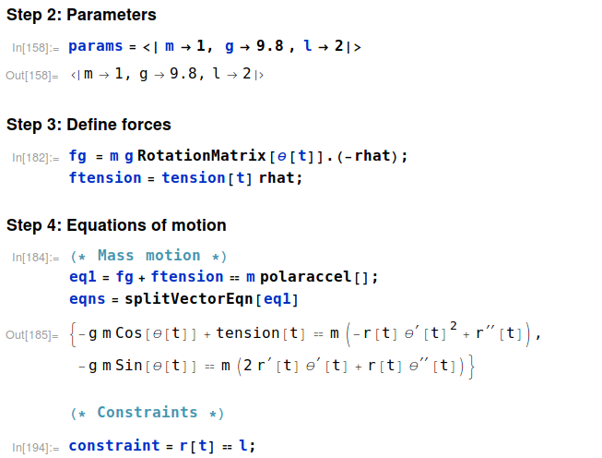

# 

# 

## A perfect segway

All that needs to change is replacing with on the rhs of Newton’s equation.

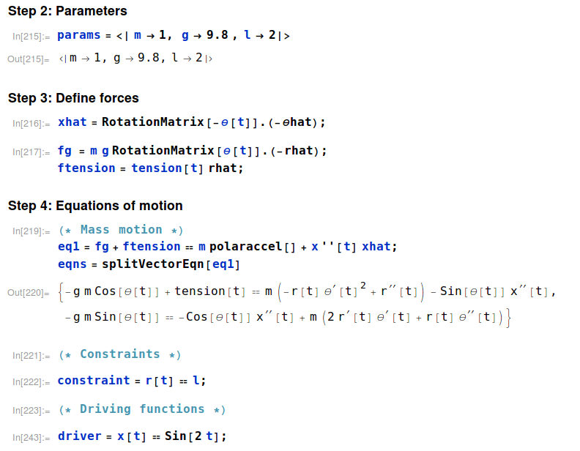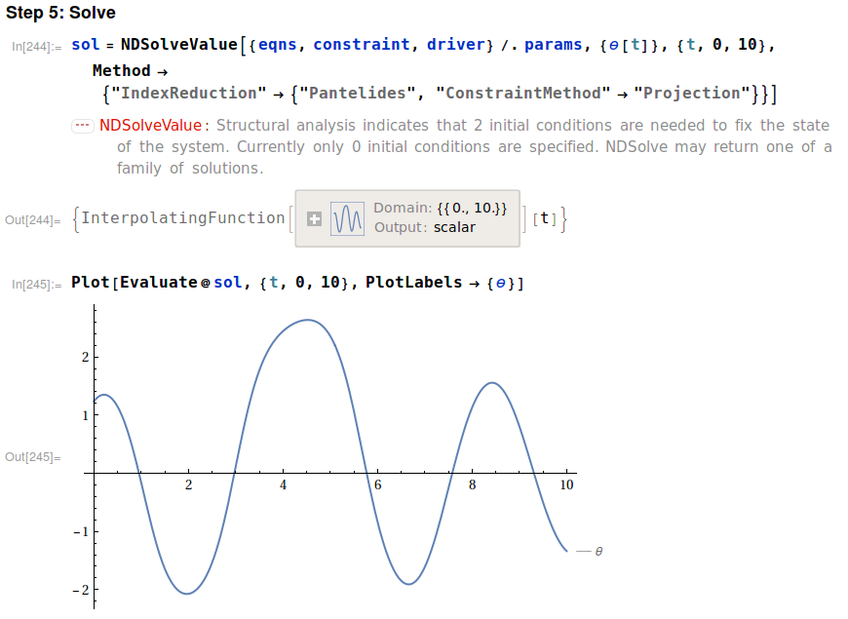

## Massy segway

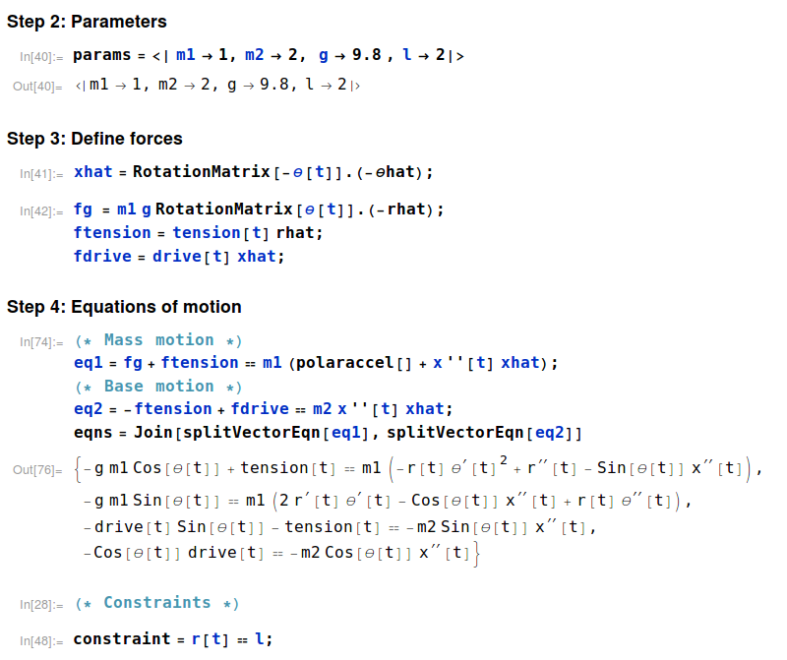

Unfortunately, I wasn’t able to get far enough to fully solve this one. I am confident I can, but I just haven’t yet.